**Declaration of interests**

The authors declare that they have no known competing financial interests or personal relationships that could have appeared to influence the work reported in this paper.

The authors declare the following financial interests/personal relationships which may be considered as potential competing interests:

**Author Declarations**

We confirm that the manuscript has been read and approved by all named authors and that there are no other persons who satisfied the criteria for authorship but are not listed. We further confirm that the order of authors listed in the manuscript has been approved by all of us.

We confirm that we have given due consideration to the protection of intellectual property associated with this work and that there are no impediments to publication, including the timing of publication, with respect to intellectual property. In so doing we confirm that we have followed the regulations of our institutions concerning intellectual property.

We understand that the Corresponding Author is the sole contact for the Editorial process (including Editorial Manager and direct communications with the office). He/she is responsible for communicating with the other authors about progress, submissions of revisions and final approval of proofs. We confirm that we have provided a current, correct email address which is accessible by the Corresponding Author and which has been configured to accept email from Joseph Del Rocco ([jdelrocco@ist.ucf.edu](mailto:jdelrocco@ist.ucf.edu)).

Signed by all authors as follows:

Joseph Del Rocco, Paul D. Bourke, Charles B. Patterson, Joseph T. Kider Jr.

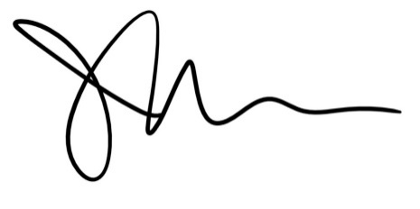

Joseph Del Rocco

University of Central Florida